**比较你与朋友的异同**

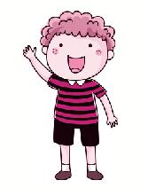

**写作任务 (Section B 3c)**

本周日，你们学校的英语角准备举办一场活动，活动的主题是“My friends”，要求介绍你的两位朋友（一位与你相似，一位与你不同），你对此活动很感兴趣，请你写一篇短文为此活动做准备。

**●【审清题目】**

**内容：**介绍你的两位朋友与你的异同。

**文体：**说明文。

**时态：**描写人物现在的情况，用一般现在时。

**人称：**描述朋友与我的共同点，用第一人称复数代词we；描写与朋友的不同点，用第一、三人称。

**●【头脑风暴】**

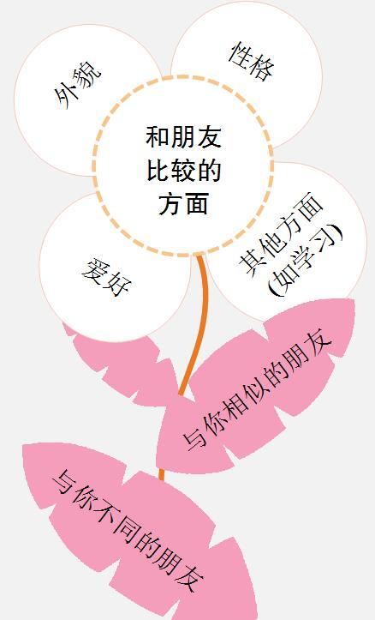

**●【提供素材】**

**◆单词&短语**

根据汉语提示，写出对应的英文表达。

1.**外貌：**tall, short, thin, heavy, strong, good-looking, handsome, beautiful, (1)_______________(中等身高), short straight hair, long curly hair, big eyes, a small nose, (2)_______________(圆脸)

2. **性格：**(3)_______________(外向的), shy, quiet, funny, (4)_______________(严肃的), smart, clever, friendly, kind (友好的), honest (诚实的), brave (勇敢的), independent (独立的)

3.**爱好：**swimming, running, fishing, cooking, reading books, playing basketball / football / tennis / volleyball ..., writing, dancing, singing, (5)_______________(下国际象棋), playing the piano / violin ..., (6)_______________(听音乐), watching films

4. 其他方面(如学习)：(7)_______________(工作努力的), lazy, careful, careless (粗心的)

**Key:**1. of medium height  2. a round face  3. outgoing

4. serious  5. playing chess  6. listening to music

7. hard-working

**◆句型**

1. We are similar to each other in many ways.

2. Both of us like / We both like ...

3. We are different from each other in ...

4. She / He is more / less ... than me.

5. She / He likes to do the same things as me.

6. She / He likes ..., but I don't like ...

7. I'm as ... as ...

8. She / He is good at / interested in / talented in ..., but I'm not.

**◆谚语**

• Better without gold than without friends.

(宁可没有金钱，不可没有朋友。)

• A friend in need is a friend indeed.

• Good friends are like stars. You don't always see them, but you know they're always there.

• A good friend is like a mirror.

• Friends are like books — you don't need a lot of them as long as they're good.

• A true friend reaches for your hand and touches your heart.

• True friends say good things behind your back and bad things to your face.

**●【谋篇布局】**

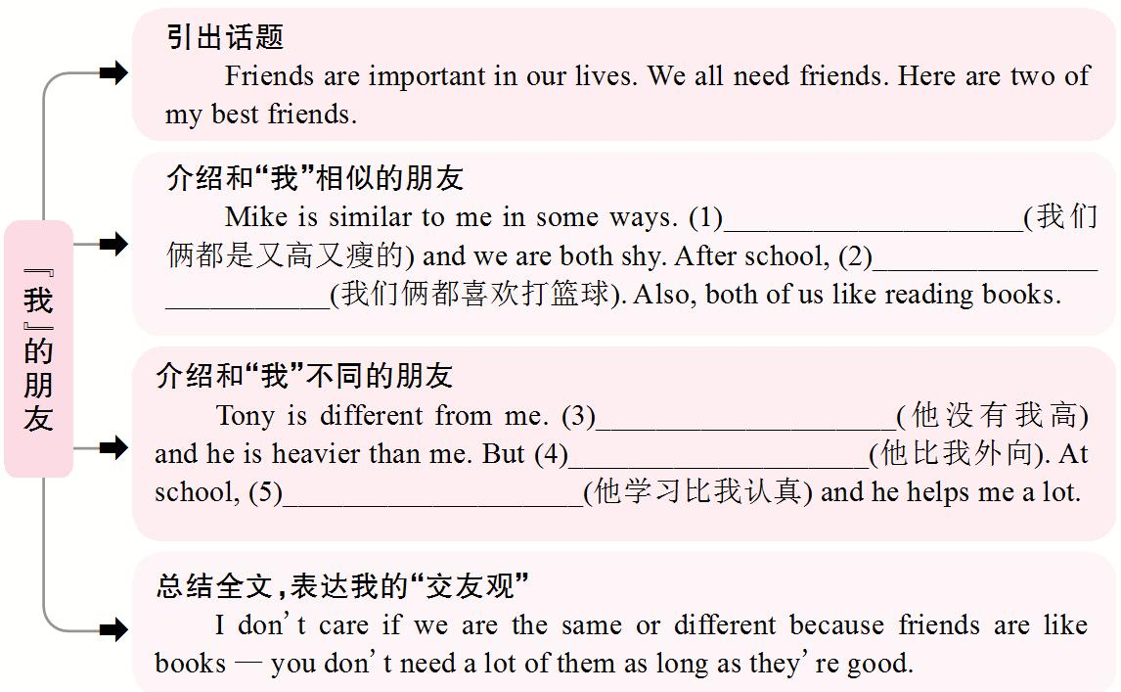

**Key:**1. Both of us are tall and thin / We are both tall and thin

2. we both enjoy / like playing basketball

3. He isn't as / so tall as me / He is shorter than me

4. he is more outgoing than me

5. he studies more carefully than me

**●【小试身手】**

同学们，请参考**【头脑风暴】**和**【提供素材】**中的内容，比较你与好友之间的异同，把你的一位好友介绍给大家。

_____________________________________________________________________

_____________________________________________________________________

_____________________________________________________________________

_____________________________________________________________________

_____________________________________________________________________